# Module 6 Activity 2: Deploying Node.JS application into Docker Using Visual Studio

# Brandon Trinkle

# IFT 458: Middleware Programming

# Professor Dinesh Sthapit

# March 29, 2025

**Module 6 Activity 2: Deploying Node.JS application into Docker Using Visual Studio**

*Task 1: Showing Docker version in the terminal.*

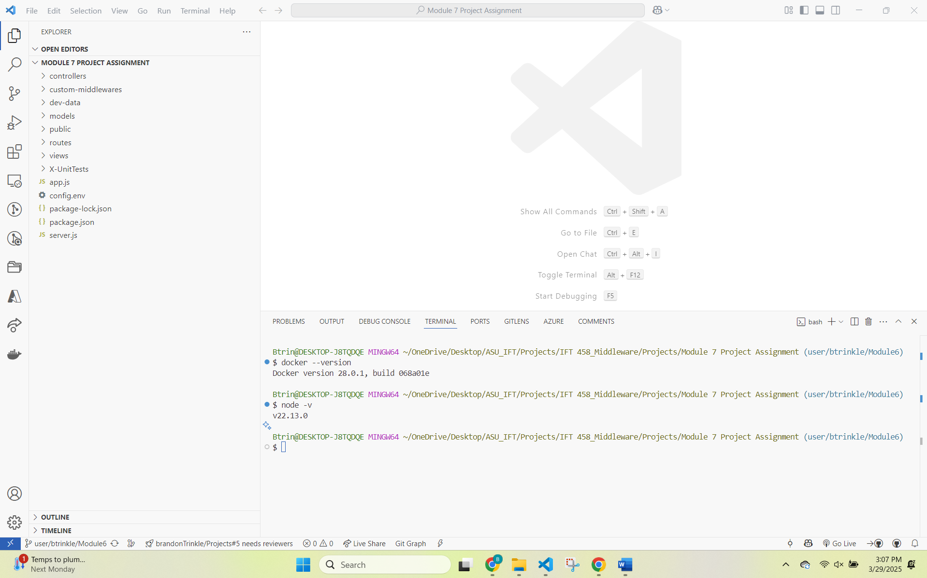

*Task 2: Showing Node.js version in the terminal.*

*Task 3: Displaying Docker extension in VS Code.*

*Task 4: Of the running Docker Desktop application.*

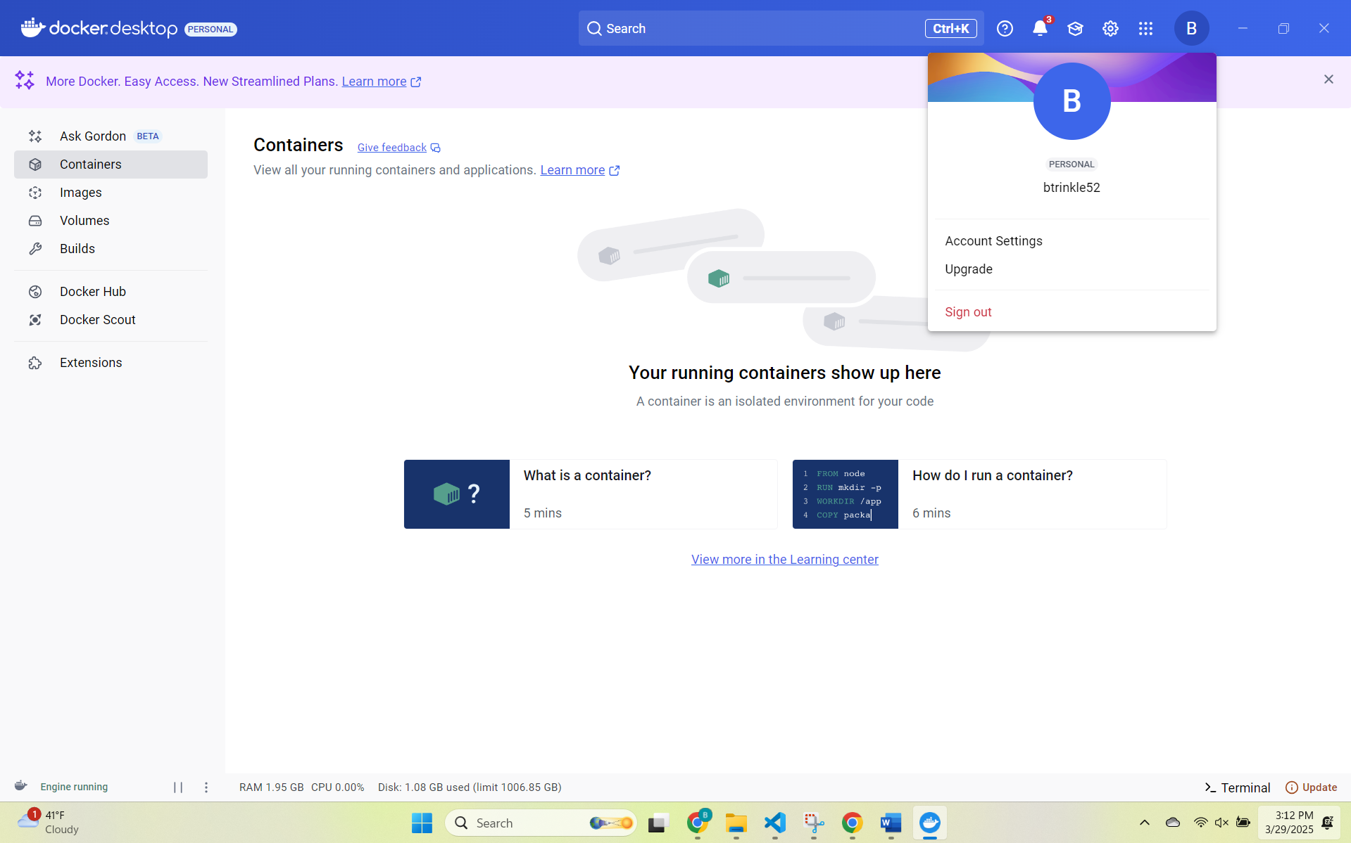

*Task 5: Showing successful installation of dependencies in the terminal.*

*Task 6: Of the Dockerfile with content in VS Code.*

*Task 7: Showing the Docker image build process in VS Code.*

*Task 8: Showing Docker container configuration*

*Task 9: Showing the running container in Docker Desktop.*

*Task 10: Of the running Node.js application in the browser.*

*Task 11: Of the terminal after executing the Docker run command.*

*Task 12: Of the interactive shell session with the running Docker container.*

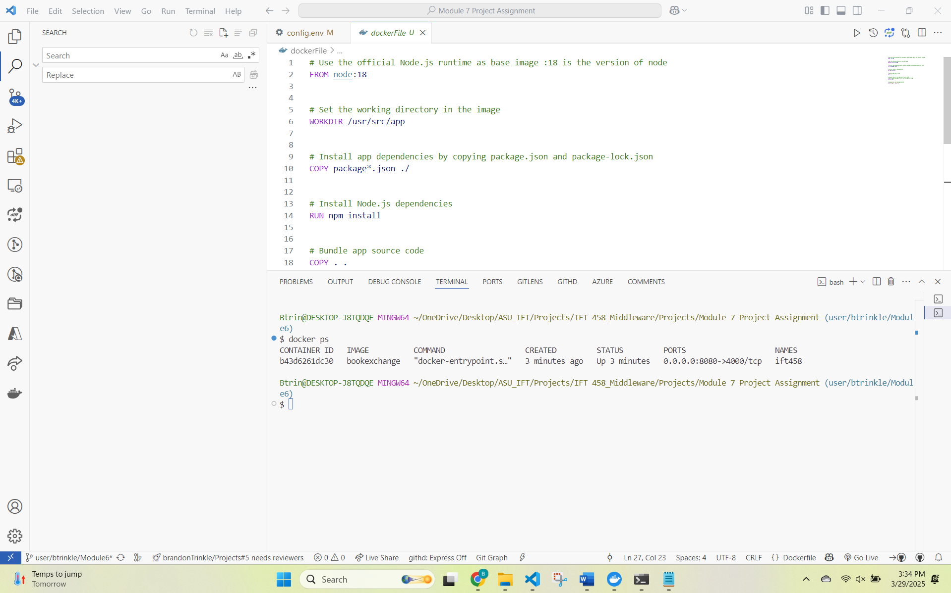

*Task 13: Showing the terminal after stopping the container.*

*Task 14: Showing the terminal after removing the container.*

